December 12, 2006

RE: Comments on the Moving Into Prosperity (MIP) Report

This document discusses the numerous concerns we have with the Moving Into Prosperity Report (hereafter, referred to as the Report) and the reasons why the Report should be subject to extensive peer-review before it is used for decision-making purposes.

- The Report Fails to Evaluate Reasonable Strategies For Actively Managing Existing Roadways to Maximize Their Functional Capacity.
Reasonable, feasible, and prudent alternatives that perform better and cost less than the TTC are not evaluated in the Report. Experience shows that there is a tremendous opportunity to enhance mobility, competitiveness and improve quality of life by applying road pricing, traffic management, improved transit service, access management and other fix-it-first strategies

The Report limits its review of congestion relief alternatives to simply adding more road capacity. It concludes that building in new corridors some distance away from existing major roadways is the most cost-effective alternative because the “right-of-way can be acquired at much lower costs, and it is more feasible to create other revenue opportunities.” This overly narrow focus on land acquisition costs precludes consideration of the significant environmental and socials costs of building on natural, undeveloped lands. Not to mention the reduced economic benefits of building away from existing centers of commerce and trade. For Texans to plan sensibly for their future, the full costs and benefits of the TTC project must be compared to strategies for actively managing existing roadways to maximize their functional capacity.

- The Report’s Economic Analysis Methodology Fails To Provide A Useful Benchmark for Determining Whether the TTC Project Should Be Undertaken.

The Report relies upon input-output modeling to quantify the indirect effects of the TTC on the economy. One problem with applying this type of economic analysis to a single alternative is that the public has no means of evaluating how an investment in the TTC project compares to other potential transportation investments. It is important to note that construction spending by itself does not necessarily bring any net income benefit over the alternative of spending the same money on other transportation investments. If the state or private developer were to invest several billion dollars in public transit, the input-output model would also show positive indirect effects on the economy. To determine whether the TTC project should be undertaken at all, a benefit-cost analysis of multiple viable project alternatives should have been conducted – not an economic impact analysis of a single alternative.

- The Report’s Assumption That the TTC Project Will Generate Financial Returns Comparable To Those Observed In The Early Stages Of The Interstate Highway System Is Seriously Flawed

The Report unrealistically assumes that the TTC project will generate financial returns "comparable to those observed in the early stages of the interstate highway system". The Report explains that the basis for quantifying TTC financial returns comes from two studies prepared for the Federal Highway Administration (FHWA). However, a close review of those studies provides convincing evidence that the assumption that TTC impact will resemble that of the interstate highway system is seriously flawed. As illustrated in the chart below, the rate of return on highway capital has plummeted since construction of the interstate highway system during 1950’s and 1960’s.

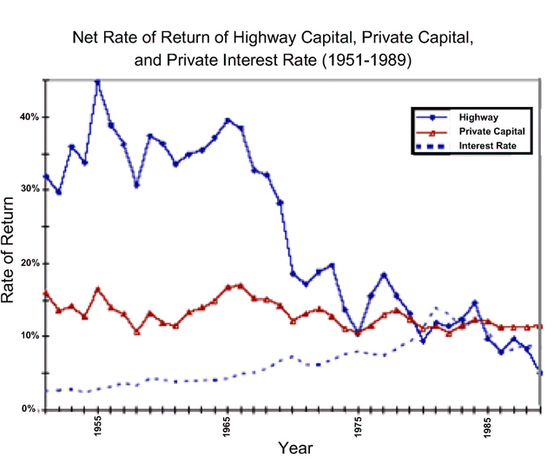
Source: M. Ishaq Nadiri and Theofanis P. Mamuneas, Contributions of Highway Capital to Industry and National Productivity Growth, Federal Highway Administration, Office of Policy Development, September 1996

The Report attempts to justify its assumption claiming that "because the TTC represents a fundamental and innovative change in the infrastructure complex of the state in areas with substantial congestion," the project will somehow be able to break the historical cycle of reduced returns on highway capital investment. At a minimum, this assumption should be peer reviewed by qualified transportation finance experts.

- The Report’s Relies Upon A Discount Rate That Does Not Accurately Reflect The Actual Opportunity Cost of Capital To Private Road Developers.

The Report uses the Net Present Value (NPV) measure to compare the benefits and costs of the TTC project. Calculating NPV requires that all benefits and costs over the project's life-cycle to be discounted to the present using an appropriate discount rate. The Report mistakenly assumes that a 3% real (inflation-adjusted) discount rate reflects the actual opportunity cost of capital. While a 3% real discount rate may be appropriate if the TTC project were being financed entirely by the State of Texas, it does not accurately reflect the cost of capital for a project that is to be financed, in large part, by private road developers. According to the TTC-35 Master Development Plan, the private developer will pay all capital investment costs, including approximately $5.9 billion in initial engineering. Thus, the discount rate needs to reflect the private developers cost of capital - not the State's. Present values of costs and benefits 25 years in the future can be change by more than a factor of 5 depending on the discount rate used.

The Perryman Group. June 2006. Technical Analysis to Accompany Moving Into Prosperity, The Potential Impact of the Trans-Texas Corridor on Business Activity in Texas: An Analysis of the Effects in Key Trans-Texas Corridors and the State of Texas. P. 13.
M. Ishaq Nadiri and Theofanis P. Mamuneas. 1996. Contributions of Highway Capital to Industry and National Productivity Growth, Federal Highway Administration, Office of Policy Development, September and M. Ishaq Nadiri and Theofanis P. Mamuneas, 1998. Contribution of Highway Capital to Output and Productivity Growth in the US Economy and Industries, Federal Highway Administration, Office of Policy Development.

